Full paper title [Title]

**Title First name Last name1, Title First name Last name2, Title First name Last name3 [style: Authors]**

1 Affiliation name (in the order: Research lab, Department, Faculty, University), Country, e-mail [style: Affiliations]

2 Affiliation name (in the order: Research lab, Department, Faculty, University), Country, e-mail [style: Affiliations]

3 Affiliation name (in the order: Research lab, Department, Faculty, University), Country, e-mail [style: Affiliations]

**Abstract**

These guidelines provide instructions to format your paper, specifically on the way how text should be formatted, table and figure captions, and references cited. It is advised to write directly into the template and use the formatting styles, indicated in yellow and blue, that should be deleted before final submission. **The full paper** should be submitted in a Word document (.doc or .docx) and it **must be between 12 and 14 pages**, **including figures, tables and references**. The abstract should be a single paragraph and should follow the style of structured abstracts, but without headings [no more than 200 words, one paragraph only]. [Abstract body]

**Keywords:** First Keyword, Second Keyword, Third Keyword, Fourth Keyword, Fifth Keyword. [3 to 5 Keywords]

# **Introduction [Heading 1]**

The introduction provides sufficient information for the reader to understand and place the study in a broad context. It also supplies a rationale for the study and highlights why it is important. It should define the purpose of the work and its significance, including specific hypotheses or research questions. It is expected that authors reflect on the current state of the research and provide references to key publications. The introduction section should end with a description of the structure of the paper. [Text body]

## **Introduction subsection [Heading 2]**

In case you need subsections, please use Heading 2 and Heading 3 styles for their title. No more than three levels of headings should be used. When mentioning and referencing specific work, please use author and year in parenthesis (Surname, 2003). If you are citing several works at the same time, all relevant surnames and years should be included in parenthesis chronologically (Surname, 2010; Surname, 2014). Citations of works by two authors should have ‘and’ (not an &) between the names (Surname and Surname, 2015). Citations of works by three or more authors should have the first author followed by *et al* in italics (Surname *et al*., 2021). Furthermore, “*When you include a quote in the text, this should be in italic, contained quotation marks and listing in the reference author(s), year of publication, as well as page number or page range*” (Surname, 2020: 5-8). [Text body]

### ***Introduction subsection* [Heading 3]**

In case you really want to introduce more levels to your structure use Heading 3 style. This is not recommended. [Text body]

# **Methodology [Heading 1]**

The methodology section is very important as it ensures the robustness of your approach, the validity of your results and the replicability of your research. All new methods used in research should be described in detail while well-established methods can be briefly described and appropriately cited. Mention the full name and version of any software used and make clear whether the computer code used is available. You should also clearly describe the data you have used. Illustrate your method and workflow with figures (in colours or black and white or tables). Remember that each figure included in your paper should be referred to in the text and numbered following the order of appearance (Figure 1). Figures must be inserted in the document as JPEGs, within the limits imposed by the page margins. Do not insert loose objects such as arrows, lines or text boxes. [Text body]

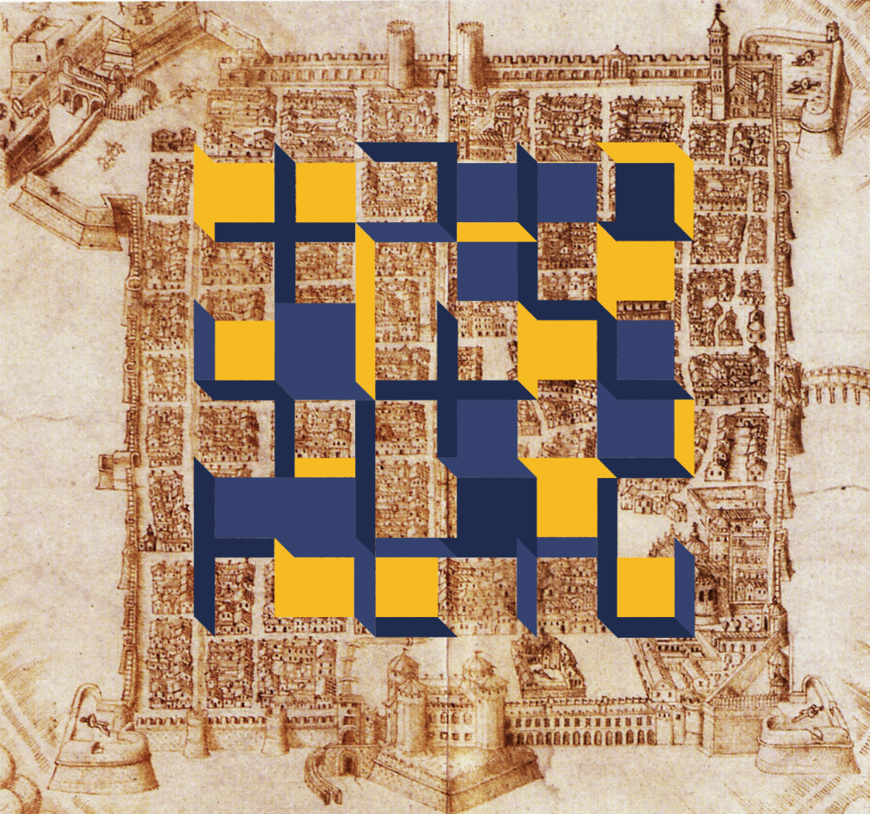

*Figure 1. Always include a caption and source below your image. Torino, credits: ISUF 2025. [Figure caption]*

Several rules apply to tables, figures and graphics. Firstly, the text should provide references to all of them and numbered following the order of appearance. For example, As shown in Table 1. Tables should be created within the MS Word document and not imported as images and should fit within page margins. Please ensure that tables do not split over more than one page. **It is highly recommended to avoid endnotes and footnotes.** [Text body]

*Table 1. Always include a caption and source above table. Table showing a set of observations and values. [Table caption]*

| **Field** | **Field** | **Field** | **Field** |
| --- | --- | --- | --- |
| Entry Field | Value | Value | Value |
| Entry Field | Value | Value | Value |
| Entry Field | Value | Value | Value |

# **Results and discussion [Heading 1]**

Provide a concise, clear and precise description of the results and their interpretation. You may use tables, drawings, figures, and diagrams to illustrate your findings. Make sure to dedicate enough space for discussing your results and to reflect on how they can be interpreted from previous studies’ perspectives and the working hypotheses/research questions. The findings and their implications should be discussed in the broadest context possible, and the limitations of the work should be highlighted. [Text body]

# **Conclusions [Heading 1]**

The paper should be completed with your conclusions. Future research directions may also be mentioned. Please note that every reference cited in the text should also be present in the reference list and vice versa. **Citations should follow the Harvard referencing style, which is also used in the Journal of Urban Morphology.** References in the reference list section should be arranged first alphabetically and then further sorted chronologically, using the appropriate pre-defined paragraph style. [Text body]

# **Acknowledgements [Heading 1]**

An optional acknowledgement section of up to 150 words may be included. This should list individuals or entities providing material or immaterial support to the research. For research paper, if the research presented was supported by a funding source, include the funder’s name and grant information. [Text body]

# **References [Heading 1]**

Castex J, Depaule JC, Panerai P (1977) Formes urbaines: de l’îlot à la barre. Dunod, Paris [Reference list]

Conzen MRG (1960) Alnwick Northumberland: a study in town-plan analysis, Institute of British Geographers Publication 27. George Philip, London

Cullen G (1961) Townscape. Architectural Press, London

Hillier B, Hanson J (1984) The social logic of space. Cambridge University Press, Cambridge

Jacobs J (1961) The death and life of great American cities. Random House, New York

Lynch K (1960) The image of the city. MIT Press, Cambridge

Morris AEJ (1972) History of urban form: before the industrial revolution. George Godwin Limited, London

Moudon AV, Hess P, Snyder M, Stanilov K (1997) Effects of site design on pedestrian travel in mixed use, medium-density environments. Transp Res Rec 1578:48–55

Muratori S (1959) Studi per una operante storia urbana di Venezia I. Istituto Poligrafico dello Stato

Rossi A (1966) L’architettura della città. Marsilio, Padova